**TASK – 4**

**CYBERSECURITY INTERN**

MADHAV P RAJEEV

[Madhavrajeev93@gmail.com](mailto:Madhavrajeev93@gmail.com)

**Configure and test basic firewall rules to allow or block traffic**

This project demonstrates the configuration and testing of basic firewall rules using Windows Firewall and UFW (Uncomplicated Firewall) on Linux. Firewalls play a vital role in securing systems by controlling network traffic based on predefined rules. By blocking and allowing specific ports, we can manage which services are accessible and protect the system from unauthorized access. The project involves creating and testing rules such as blocking Telnet (port 23) and allowing SSH (port 22), followed by verifying and documenting the results.

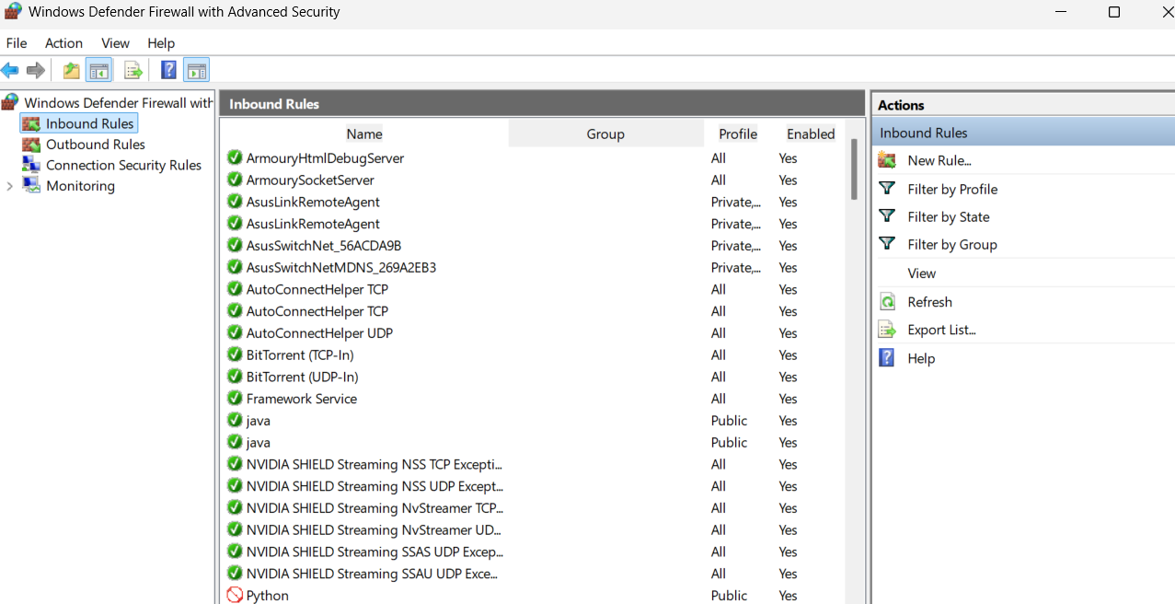

Addition of a new rule to block port 23(telnet)

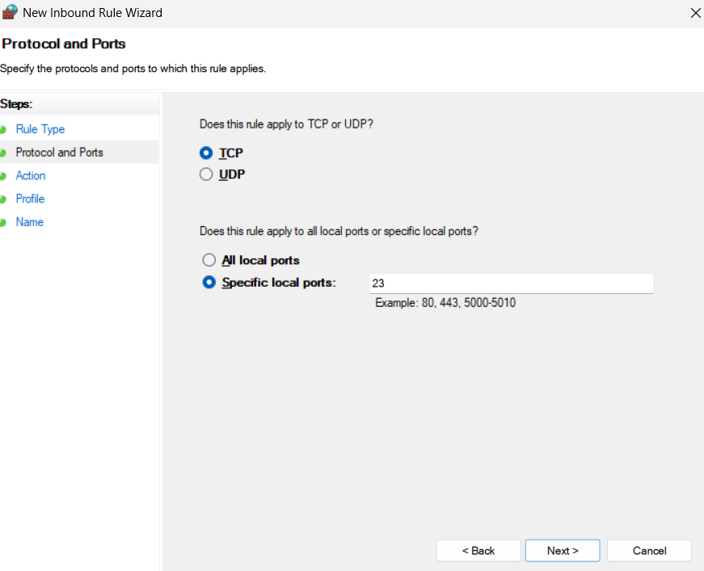

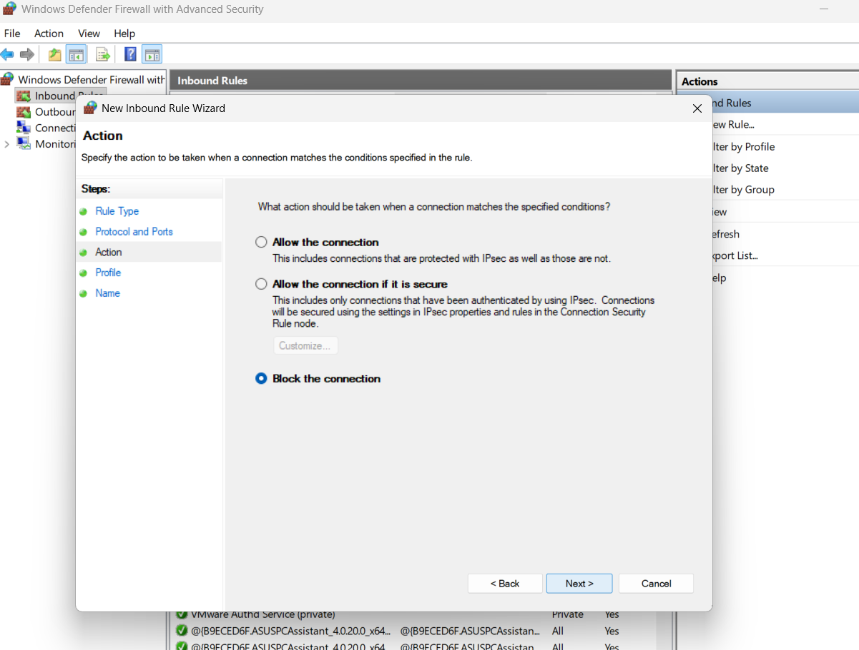

Connecting with telnet localhost 23 failed because the firewall was blocking it



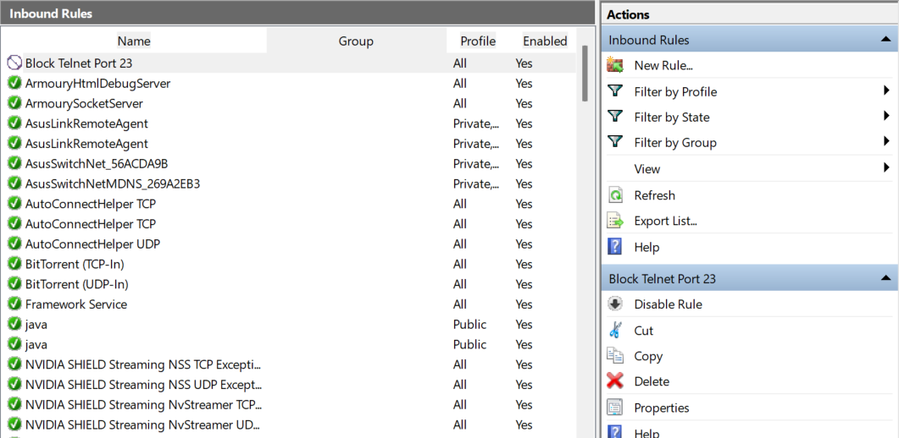

And the rule was removed after the test



**Summary :**

How the Firewall Filters Traffic

A firewall works like a security guard for your computer’s network. It checks every packet of data trying to enter or leave the system and decides whether to allow or block it based on predefined rules.

Rules are based on criteria like:

Port number (e.g., block Telnet on port 23, allow SSH on port 22).

Protocol (TCP/UDP).

Source or destination IP address.

Direction (inbound or outbound traffic).

Inbound filtering: Controls what outside traffic can reach your system (e.g., blocking Telnet prevents attackers from connecting).

Outbound filtering: Controls what your system can send out (e.g., preventing apps from sending data over certain ports).

In the project :

The firewall blocks port 23, so Telnet traffic cannot connect.

The firewall allows port 22, so SSH remains accessible.

In short: The firewall enforces security by permitting only trusted traffic and blocking unwanted or risky connections, protecting the system from unauthorized access.